CLASSIFIED
Copy _____ of _____
Air Assault Task Unit
1st Battalion, 7th Cavalry Regiment
1st Armored Brigade Combat Team
1st Cavalry Division
242000CMAR18

OPERATIONS ORDER (OPORD):
JUNIPER SPEAR
BATTALION TO TASK UNIT OPERATIONS ORDER
REFERENCES:
- Intelligence (S2) and Operations (S3) Integrated Overlays
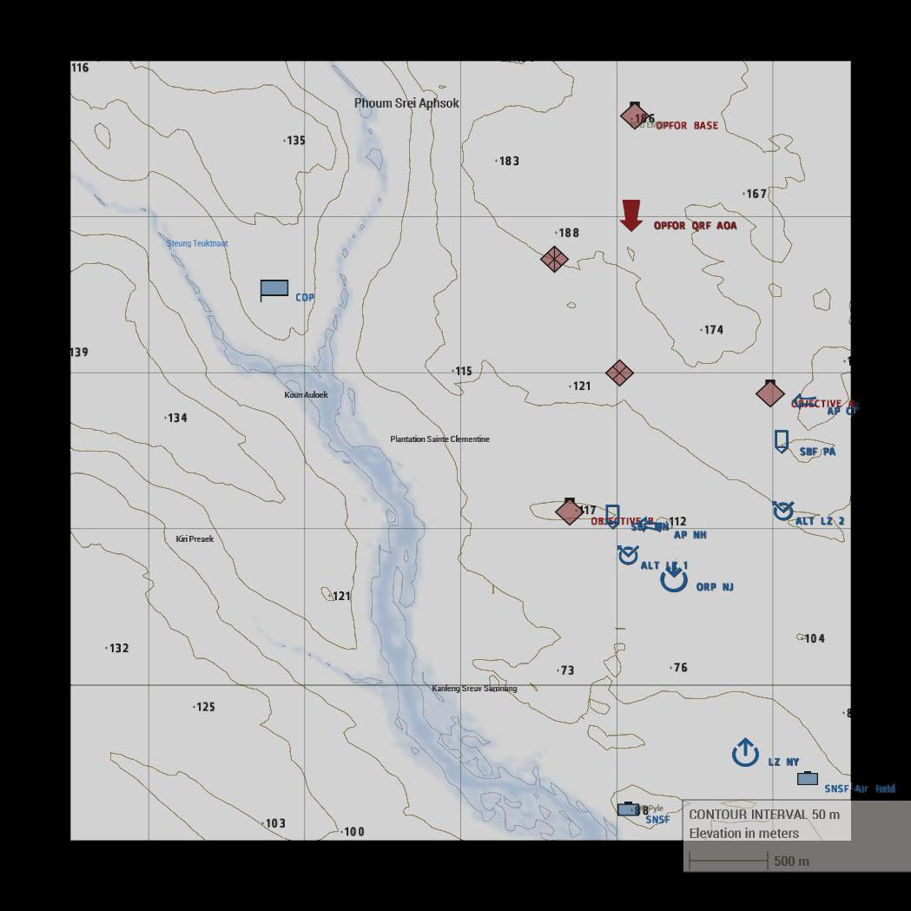
- Overlay - Objective A
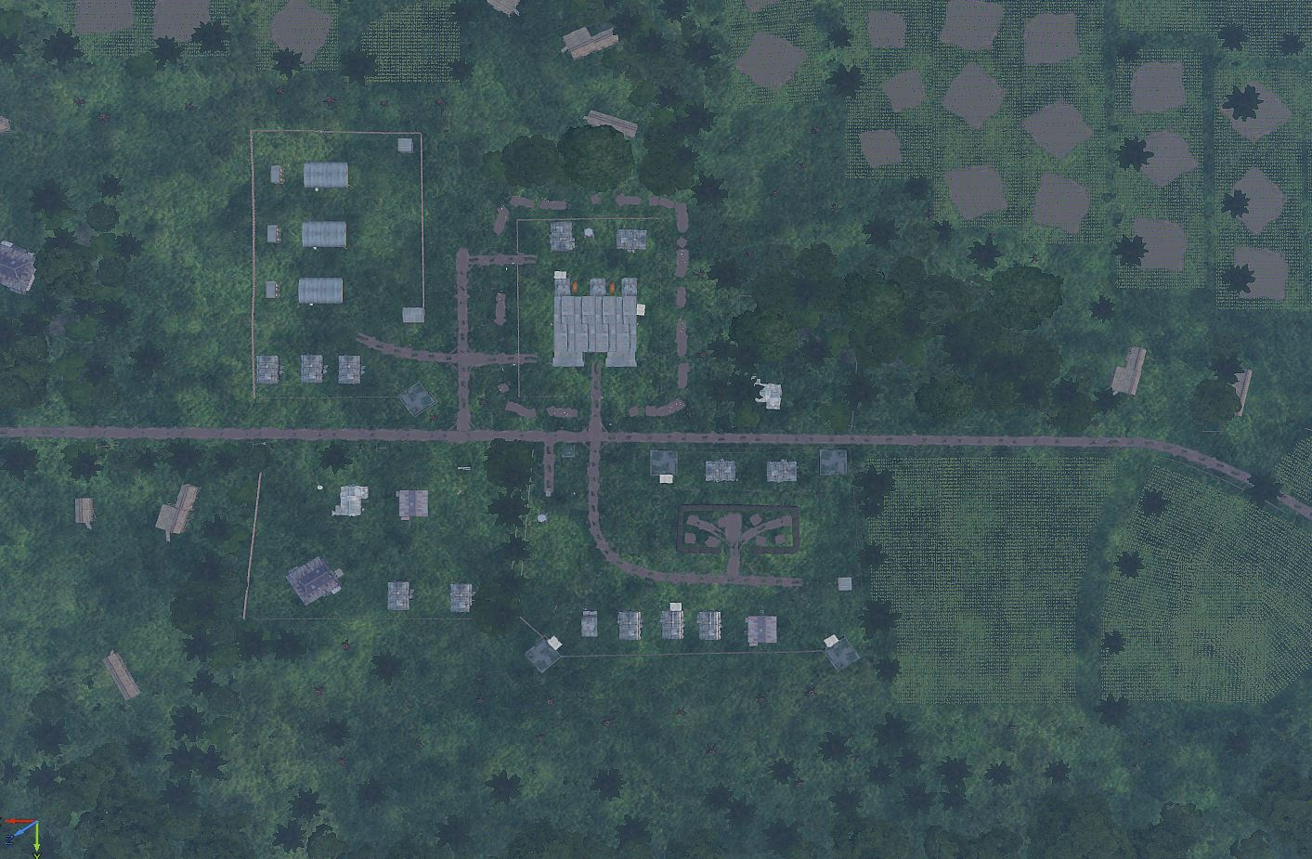
- Overlay - Objective B
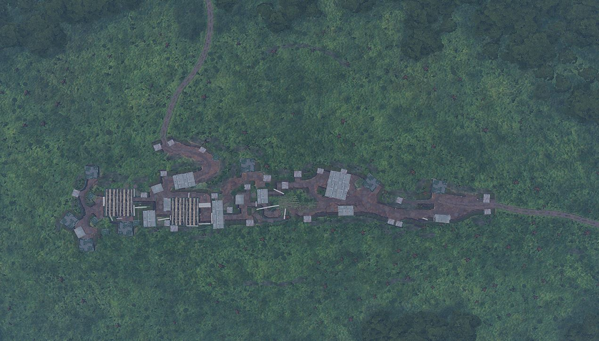
Task Organization:
Air Assault Task Unit:
Headquarters Section (Misfit 5-6)
Light [Air Assault] Infantry Platoon (Misfit 1-4)
Heavy Weapons Section (Havoc 1)
Medical Section (Mustang 6)
S3 Operations Section (Apollo 1, 5-6)
Ranger Section (Roughneck 6)
- Situation.
Per HBCT to Battalion FRAGO 111820CMAR18, Umar and the WMDs have escaped Mogadishu, and slipped west towards the Kenyan border, evading 2-5 CAV. Upon reaching the town Afmadow, Umar’s convoy broke into two parts, with one element heading west through the desert, and the other southwest into the jungle. 1-7 CAV has been retasked by Brigade to pursue the convoys, and subsequently moved from Mogadishu to Afmadow. After reaching Afmadow 1-7 CAV detached it’s Armored and Mechanized Infantry Task Unit to pursue the convoy to the desert west, and it’s Air Assault Task Unit to pursue the convoy southwest into the jungle.
The Air Assault Talk Unit has moved from Afmadow and occupied a hasty Combat Outpost (COP) west of the convoys last known position, blocking further movement west. From the COP the Air Assault and Ranger Task Unit it is to conduct missions to find Umar and WMDs.
The Ranger section will insert into an undisclosed position to provide reconnaissance and establish an ambush point to prevent OPFOR reinforcement from the north.
  - Enemy Forces.
    - Weather and light data general forecast for the length of the operation:
High Temp: 75 deg F
Low Temp: 60 deg F
Sunrise:0545z
Sunset: 1912z
Overall Weather: Clear, dry
Illumination (Night): N/A
    - Terrain (OCAKA):
      - Observation and Fields of Fire (FOF) are limited for BLUFOR, and OPFOR patrolling, given the dense jungle terrain. OPFOR has cleared FOFs around the objectives and have the high ground.
      - Cover and Concealment is optimal for entrenched OPFOR at objective sites, which are heavily fortified. Patrolling OPFOR and BLUFOR can take advantage of the concealment provided by dense cover.
      - Obstacles are unlikely to be found in the jungle.
      - Key or Decisive Terrain for this mission are the jungle between the LZ, and the compounds known as Objective A (Grid 069-018) and Objective B (Grid 056-011). The terrain between the LZ and Objectives is dense and relatively flat jungle. Objective A is a barracks complex that is lightly fortified, primarily with razor wire (See Overlay #2). Objective B is a bunker complex that is protected by sandbags, earthen fortifications, and razor wire.
      - Avenues of Approach for OPFOR are from the north in the event they are able to rally and reinforce, or counterattack.
    - Identification of enemy forces (composition). OPFOR is a guerrilla faction, and non-uniformed. S2 through US-JSOC confirms all personnel at the objectives is OPFOR. If they are armed at the objectives, or armed and patrolling, and not in SNSF they are likely hostile.
    - Location(s):
      - COP @ 037-026 - BLUFOR (1-7 CAV).
      - LZ NY @ 067-095 - BLUFOR, SNSF OCCUPIED.
      - OBJECTIVE B @ 056-011 - OPFOR, POSSIBLE ANTI-AIR.
      - OBJECTIVE A @ 069-018 - OPFOR, KNOWN ANTI-AIR.
      - OPFOR COMPOUND @ 060-036 - OPFOR, KNOWN ANTI-AIR.

    - Activity: OPFOR is garrisoned in, along with patrolling around, known locations. OPFOR is aware of BLUFOR presence and in a defensive posture.
    - Strength: OPFOR are heavily entrenched in the north-western portion of the Area of Interest. Estimates place total OPFOR strength at around 1,000 soldiers, augmented by CSW, motorized, and a few mechanized assets, including Anti-Air.
    - Probable course(s) of action when contacted: OPFOR will likely remain in place and fight, and or make first contact through movement to contact (patrols). Given high morale, if decisively engaged, they will fight to the death, and likely not to surrender.
  - Friendly Forces.
    - Mission and concept of next higher unit: The Air Assault Task Unit will block the convoy from moving west by establishing a hasty COP, then conduct reconnaissance in force through a series of raids at the areas suspected to hold, or know the whereabouts, of Umar and the WMDs.
    - Location and planned actions of units to the left, right, front, and rear: Battalion Headquarters has been established at Afmadow, and the Task Units are moving as self-contained elements. Air Assault Task Unit Headquarters has been established at the COP (Grid 037-026).
    - Units providing fire support:
      - Mortars: Not available.
      - CAS: 7-17 CAV to provide CAS via AH-64, as well as 2-227 AVN may provide CAS via UH-60 if needed.
      - Artillery: Not available.
  - Attachments/Detachments.
    - Attachment: S3 and S6 detachments will accompany Air Assault Task Unit HQ to provide command and logistics support. CBRN attachments will be available once the WMDs have been seized and secured.
    - Detachment: None.
- Mission.
Reconnaissance in Force (Raid) Objectives A and B. Occupy the objectives and search for any information leading to the whereabouts of Umar and the WMDs.
- Execution.
The intent is to block Umar’s convoy from moving west, then ascertaining Umar and the WMDs whereabouts.
  - Concept of the Operation: The task unit will move from the COP to LZ NY via UH-60. Once reaching the LZ, the task unit will move to ORP NJ, where it will then split into two elements. One element will move to AP NH and the other to AP CT. Once both elements are in place they will conduct a simultaneous assault on Objectives A and B. Once secured, the task unit will Exfil via UH-60 back to the COP to consolidate and plan for future missions.
- Maneuver: The mission will consist of the following movements:
  - Movement from COP to LZ NY.
  - Movement from LZ NY to ORP NJ.
  - Movement from ORP NJ to AP NH (Misfit 1/2)
  - Movement from ORP NJ to AP CT (Misfit 3/4 and Havoc)
  - Setup SBF MN at Objective A
  - Setup SBF PA at Objective B
  - Raid Objectives A and B
  - Conduct Search of Objectives
  - Exfil to COP
- Fires: N/A
  - Tasks to Maneuver Units.
- Reconnaissance will be provided by 7-17 CAV through coordination with Apollo 6 and Pegasus.
- Security, R&S, EPW, Aid and Litter, and demolition will be handled by the Security Squad.
  - Tasks to Combat Support Units.
    - Task Unit medical level support only. Task Units must supply in field medical support.
    - Transport will be provided by UH-60 (2-227 AVN).
    - All other combat support will not be available for this mission.
  - Coordinating Instructions.
    - Order of movement, formations, and movement techniques.
      - COP to LZ NY
        - Raider-1: Forward Recon and CAS
        - Buffalo-1: Misfit-1
        - Buffalo-2: Misfit-2
        - Buffalo-3:Misfit-3
        - Buffalo-4: Misfit-4, Havoc-1
      - See III(A)1 for further movement instructions. Specific formations and techniques will be based on Commanders’ METT-TC assessments.
    - Actions at halts (short/long). SOP.
    - Routes (primary/alternate).
      - COP to LZ NY
      - LZ NY to ORP NJ
    - Departure and reentry of friendly lines. N/A.
    - Rally points and actions at rally points. RPs will be established based on Commanders’ METT-TC analysis, and intelligence gathered during conduct of operation.
    - Actions at danger areas. SOP.
    - Actions on enemy contact. React to Contact. Execute appropriate battle drill.
    - Reorganization and consolidation instructions. Consolidate on objectives if possible.
    - Fire distribution measures. SOP.
    - Fire control measures. Engage the greatest threat first.
    - MOPP levels. MOPP Ready.
    - Troop safety and operational exposure guidance. Nuclear radiation may be present around the WMDs. Likelihood of triggering WMDs low, although they may be trapped. Use extreme caution.
    - Time schedules (rehearsals, backbriefs, inspections, movement). TBD.
    - Priority Intelligence Requirements (PIR).
      - OPFOR composition and capabilities.
      - Locations of IEDs, VEIDs, and other ambush sites.
      - Location of WMDs and/or Umar.
    - Debriefing requirements. See PIR above.
    - Reports. ACE and SALUTE reports after all OPFOR contact, SALUTE upon observation of all OPFOR.
    - Rules of Engagement (ROE). Civilians may be present at hamlets throughout the Area of Interest. PID all targets before engaging. Any show of hostile action or intent is justification for engagement.
- Service Support.
  - General.
    - SOPs in effect for sustainment operations. None.
    - Current and proposed trains/resupply/cache points. ALZs to be established en-route
    - Casualty and damaged equipment.
      - CCPs to be established by Mustang-6.
      - MEDEVAC/CASEVAC PZ to be designated PRN by Apollo or Mustang.
      - A Buffalo will be re-tasked to provide insert and medevac support.
    - Special instructions for medical personnel. High tempo operation CCP designation. Coordinate with Apollo to synchronize CCP and resupply action.
  - Material and Services.
    - Supply:
      - Class I: SOP.
      - Class II: SOP.
      - Class III: SOP.
      - Class IV: N/A
      - Class V: Ammunition will be resupplyable via UH-60 (2-227 AVN).
      - Class VI: N/A.
      - Class VII: SOP.
      - Class VIII: SOP.
      - Class IX: SOP
      - Class X: N/A.
      - Distribution Methods. UH-60 via 2-227 AVN from COP.
    - Transportation.
      - Ground. Not available.
      - Air:
        - Buffalo-1
        - Buffalo-2
        - Buffalo-3
        - Buffalo-4
    - Services. SOP
    - Maintenance (weapons, equipment, vehicles). N/A.
  - Medical Evacuation: Casualties need to be treated in field. In event of critical wounded, CASEVAC will be provided by UH-60 back to COP.
  - Personnel:
    - All reinserts will be coordinated through S3 Officer in Charge (Apollo) and Apollo units.
    - All EPWs will be detained, searched, and cleared of all weapons and equipment and left at CCP (location TBD).
  - Miscellaneous:
    - Special equipment.
      - M2 (.50 Caliber) CSW
      - MK19 (40mm) CSW
    - Captured equipment. Destroy in place, unless strange or unique. In case of strange or unique, case with or if can’t be moved make a sketch and destroy it.
- Command & Signal.
  - Command.
    - HHC 1ABCT is based out of FOB [Classified], Kismayo.
    - Battalion CP located at Afmadow, Somalia.
    - Task Unit CP is located at COP (Grid 037-026)
    - Succession of Command.
      - S3 Officer in Charge (Apollo-6)
      - Infantry Platoon Leader (Misfit-6)
      - Infantry Platoon Sergeant (Misfit-7)
      - Aviation Element Leader (Pegasus)
    - Adjustments to the unit SOP. None.
  - Signal
    - SOI. Standard SOI per Battalion.
    - Method of communication by priority. Short-range radio, Long-range radio, runner.
    - Pyrotechnics and signals. SOP + SL & up fix IR strobes during CAS
    - Codewords. None.
    - Challenge and password (behind friendly lines). Log / Ticket
    - Number combination (forward of friendly lines). 24
    - Running password. Garry Owen.
    - Recognition signals (near/far, day/night). Any combination of 3 lasers.
    - Special instructions for RTOs. None.

AUTHENTICATION 1LT Argus, J.
S3 Officer in Charge

